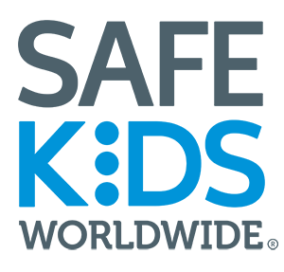
1 Inventa Place
6th Floor West
Silver Spring, MD 20910

[Date]

Dear [name],

The biennial Safe Kids Worldwide Childhood Injury Prevention Convention (PrevCon) is the largest gathering of safety professionals in the world dedicated solely to unintentional childhood injury prevention. Safe Kids Worldwide convenes leading experts, advocates, academic researchers, health care providers, manufacturers, public health practitioners, educators, and policymakers with the aim of increasing our collective impact. The next convention will be October 15 – 18, 2025 at the Gaylord National Resort & Convention Center in National Harbor, MD.

Through interactive panel discussions, breakout sessions, and networking opportunities, PrevCon attendees share cutting-edge research, best practices, and innovative strategies to drive real change.

We know your organization’s employees have competing priorities and other conferences to choose from. However, there are several key reasons why PrevCon is the go-to convention for child injury prevention professionals. Attendees of PrevCon will:
- Learn from leading experts in childhood injury prevention and public health.
- Engage in discussions on solutions that prioritize the needs of children in communities where our efforts can have the greatest impact.
- Gain hands-on knowledge to implement evidence-based strategies that work.
- Network with professionals from healthcare, academia, policy, and advocacy who share your commitment to child safety.

We are immensely grateful for your continued support of Safe Kids Worldwide and our mission to prevent childhood injuries. PrevCon offers a unique opportunity for attendees to deepen their impact within their communities. It’s a chance to connect with others addressing similar challenges, share strategies, and gain strategic insights that can be implemented upon their return.

The skills, resources, and connections gained at PrevCon are invaluable not just for the attendee but for your entire organization and the families they serve. By attending, they will return equipped with practical tools and evidence-based knowledge to further our shared mission of preventing childhood injuries and saving lives.

We sincerely hope you will consider supporting [attendee's name] ‘s participation in PrevCon and join us in advancing this important work.

Sincerely,
Torine Creppy
President, Safe Kids Worldwide

